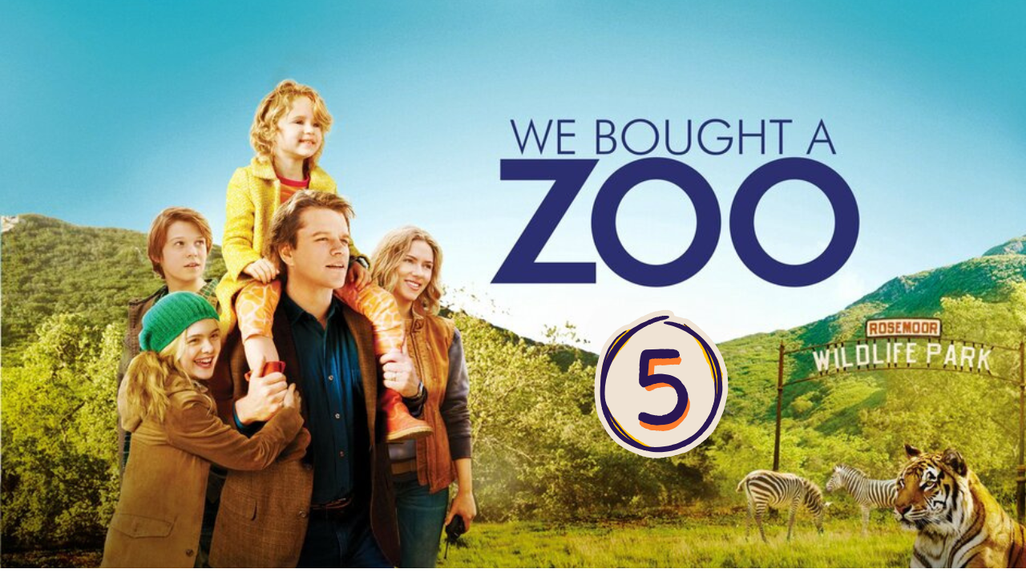
“We Bought a ZOO” (Scene 05)

Part 01 / Work on the Scene

- Scene summary:

Finally, Mr. Mee and his family arrive at their new home. He and his daughter Rosie are very excited to explore their new zoo home, unlike Dylan, who is upset. After that, they meet the zoo’s team, led by Kelly. Next, they take a tour around the property, where they see all the species living in the zoo.

- Scene Discussion & Analysis:
- Q01: How Benjamin and his kids were welcomed by the ZOO staff?
They were welcomed gracefully by the zoo team
- Q02: How many members are there in the staff?
There were six members on the staff.
- Q03: Who was the head ZOOkeeper?
Kelly was the head zookeeper.
- Q04: Who is Robin Jones?
Robin Jones is the craftsman.
- Q05: What does he look like?
He is a brunet middle-aged man. He is tall and slim. He has long street dark hair and dark eyes.
- Q06: How is Lily related to Kelly Foster?
She is her cousin.
- Q07: How old is she? and does she work there officially?
She is thirteen. No she didn’t work there officially.
- Q08: Who is Spar? And how old is he?
... .... ... ... .... ... ... .... ... ... .... ... ... .... ... ... ....
- Q09: Who is Buster? Did he lose weight? And why?
Buster is the bear. Yes he lost weight because he has been stressed out.

Part 02 / Acquired vocabulary & Grammar from the scene

- Acquired Vocabulary (OPTIONAL):

- Stressed out (adj):
- Example in a sentence:
“ He was stressed out because of the exam.”
- Moody (adj):
- Example in a sentence:
“ It’s difficult to deal with moody persons.”

- Irregular Verbs:

Infinitive | Past simple | Past participle
To feed | fed | fed
To set | set | set
To build | built | built

Part 03 / TRANSCRIPTION: improve your listening (Optional)

Task: Transcribe sentences from the scene.

- Transcribe Sentence 01
- And Peter is our visionary he builds the incloser that standards for moderns cross America
- Transcribe Sentence 02
- This is my cousin Lani she is thirteen she cant literally works here so pay here cash under the table out of my salary
Hi Lily.
She is being home schooled, she lives in the property works at jaguar that’s it.
- Transcribe Sentence 03
- ... .... ..... ..... ..... ..... ... .... ..... ..... ..... ..... ... .... ..... ..... ..... ..... ... .... ..... ..... ..... ..... ... .... ..... ..... ..... ... .... ..... ..... ..... ..... ... ..... ... .... ..... ..... ..... ..... ... ..... ... .... ..... ..... ..... ..... ... ..... ... .

Open discussion (OQ)
\
- Topic of discussion: Kelly Foster (the head Zookeeper) mentioned that Buster (the grizzly) lost a lot of weight because he has been stressed out. Do you think animals are comfortable living in the ZOO within small enclosures?? Why? And If not, why do ZOOs still exist –especially with the establishment of human rights? And what are your impression on ZOOs in general??
(Students are free to participate and interact to share their own opinions.)
(Students are encouraged to prepare their arguments before the session.)
In my personal opinion, animals shouldn’t live in zoos, which are basically big prisons for them. They are deprived of their right to live a natural life in the wild and in their natural environment. Because of human greed, people keep them in zoos just to make money. I think that if we truly care about wildlife, we should preserve it as it is.

